GLOBAL SUPERSTORE CHART CREATION

AIM:

- Draw a Pareto Chart for Running total of sum of profit. Use the dataset global superstore 2016

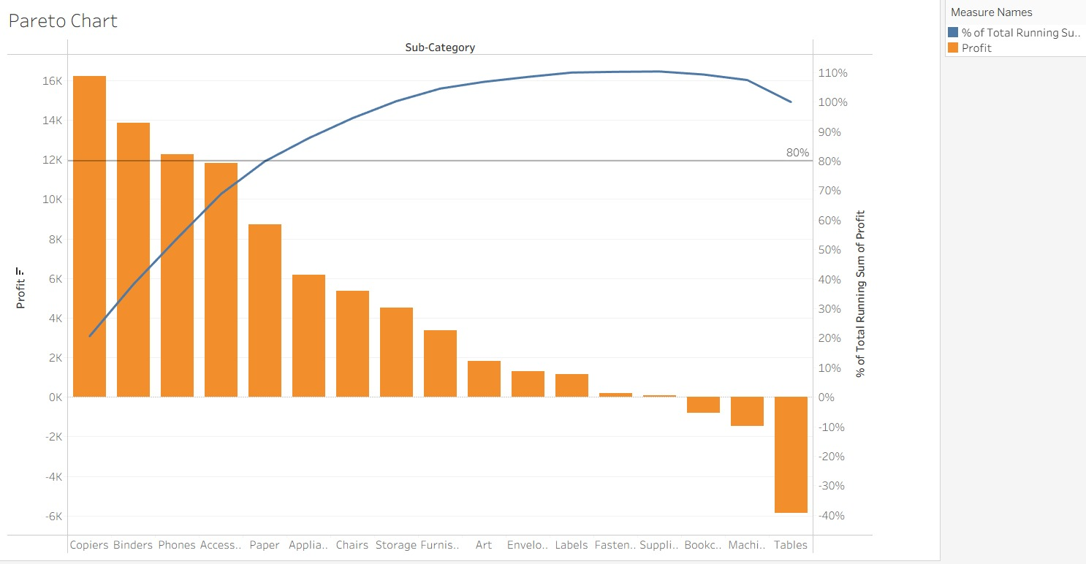

- How funnel chart shows the amount of potential revenue for each stage? – Discuss briefly. Use the dataset global superstore 2016

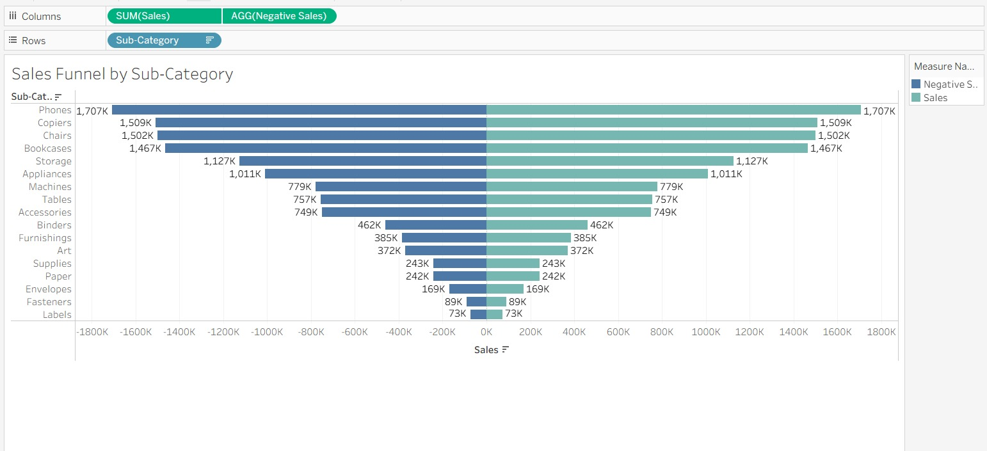

- Draw a Waterfall Chart show how the sales start, end and gets incremented over a period of time. Use the dataset global superstore 2016

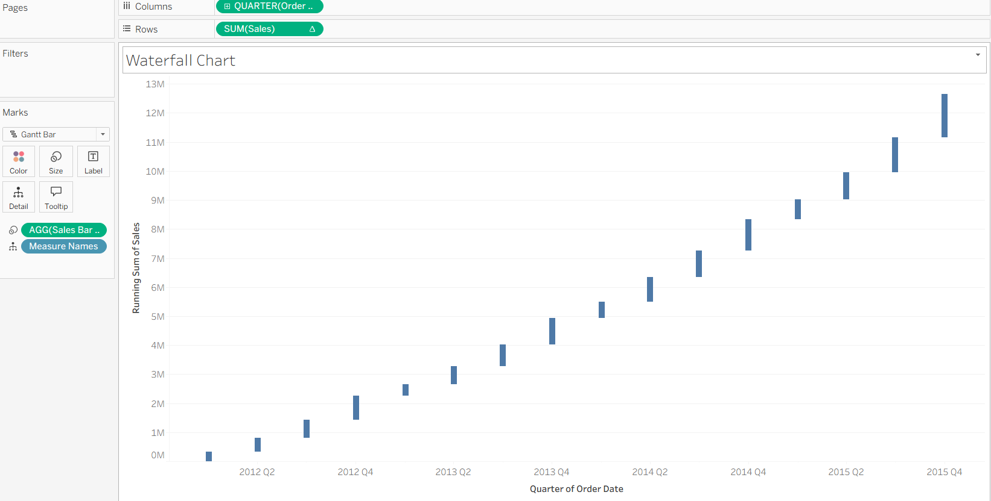

- Creates a control chart and sets up a parameter to determine control limits. Use the dataset global superstore 2016



